Healthcare Data Science Report
Assignment 3 – Data Analysis
Random forest method for predicting stroke probability ---- Based on age and other factors interacting

<Jiayu Xiong / 500037218>

Group: 5
Created: 21/05/2025

Experimental Design

1 Packages
To handle the scale and complexity of the data set, the project used multiple R packages to support tasks such as data import, preprocessing, modeling, and performance evaluation.
tidyverse was chosen because it contains a series of core packages: readr for efficient data import, dplyr for data transformation,
ggplot2 for visualization, and tibble provides a modern data frame structure, greatly simplifying the data processing.
flowzoo package is selected to assist in handling possible missing values, especially when using the na.aggregate() function to fill in missing values by column median, avoiding the bias that may be caused by mean filling, making the data completer and more reliable.
summarytools and DataExplorer are used for data summarization and exploratory analysis, facilitating a quick understanding of the basic characteristics of the data.
corrplot is used for the visualization of the correlation matrix to help identify the relationships between variables.
caret and randomForest are mainly used to build machine learning models, including feature selection and the training of random forest prediction models.
MLmetrics is used to evaluate the performance indicators of the model, while pROC and ROSE assist in the drawing of the ROC curve and handle the problem of class imbalance.
ggrepel and viridis are used to enhance the aesthetic appeal and readability of charts, respectively achieving intelligent avoidance of text tags and color mapping.
2 csv files
Data analysis still uses brain_stroke.csv, from the Kaggle platform [1]. The dataset provider has stated that the data has been cleaned and pointed out that "Unknown" in the smoking_status item indicates that the information of this patient is unavailable. So it has been removed in the subsequent training model.
3. Extract the columns of interest into the new data frame
In the random forest prediction of all variables, the factor of age has an overwhelming significant impact on whether there is a stroke. And we focus on the interaction of different factors. Therefore, the MeanDecreaseAccuracy metric is even more important, as it better reflects the interaction among metrics (Figure 1). Therefore, our subsequent analysis and model training will focus on the three factors of age, average blood glucose level and smoking status, and explore whether there is an interaction between the other two factors and age when the age factor is dominant?
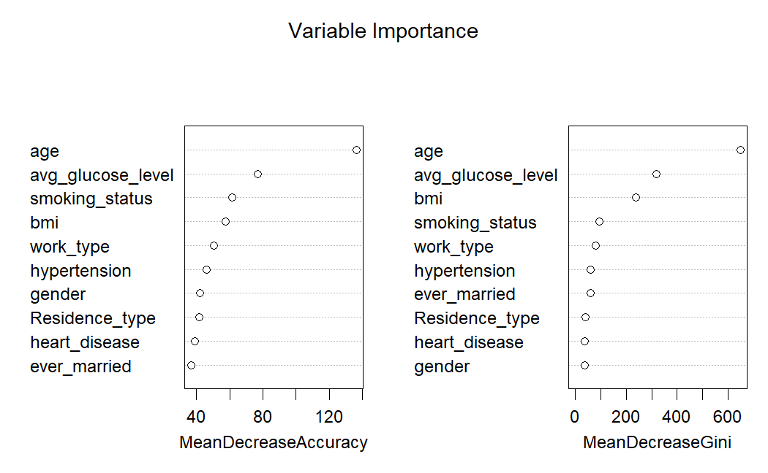

Figure 1: Variable Importance

4: PCA indicators, model training and evaluation
We used PCA to "condense" these three variables into several new variables (PC1, PC2, PC3), among which PC1 combines the three variables of age, blood glucose and BMI. This principal component mainly changes in contrast to age and BMIThe principal component.PC3 is mainly determined by the average blood glucose level, with the weight of blood glucose being the greatest. Among them, PC1 explains approximately 50.16% of the variance, and PC1 and PC2 combined explain 75.20% of the variance (Figure 2)
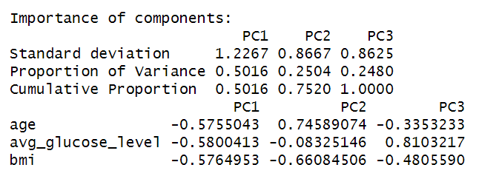

Figure 2: PC1 & PC2 & PC3

We divided the data set into 70:30 and conducted training and testing using the caret package in R. Random forest was chosen for the model. The first step is to test the overall prediction of the test set and examine the generalization performance of the model. The second step is based on samples, using models to simulate the influence of different factors on the probability of stroke, with a focus on model interpretation and univariate influence analysis. At this step, we mainly trained the random forest model, focusing on the interaction of age, age & blood glucose level, and age &bmi respectively.
Also, because the dataset is extremely unbalanced, we used the ROSE package to generate balanced training data. For the random forest model, we set 500 trees for each model respectively, and set 3 features for each tree to achieve a better prediction level.
In terms of evaluation, we assess the model by creating a confusion matrix and outproducing the accuracy rate, accuracy rate, recall rate, specificity, error rate, Kappa score and F1 score. We also plot the ROC curve or F1-score curve based on different thresholds to select the optimal threshold more intuitively. This analysis was performed using R. Mainly, the randomForest package was utilized for modeling, the MLmetrics package for calculating F1 score and recall, and the caret package for generating the confusion matrix and related statistical data.

Result

1 Summary Statistics

After establishing the research goals, we built the model and drew the prediction curve. The summary statistics of the following series were created in R studio.

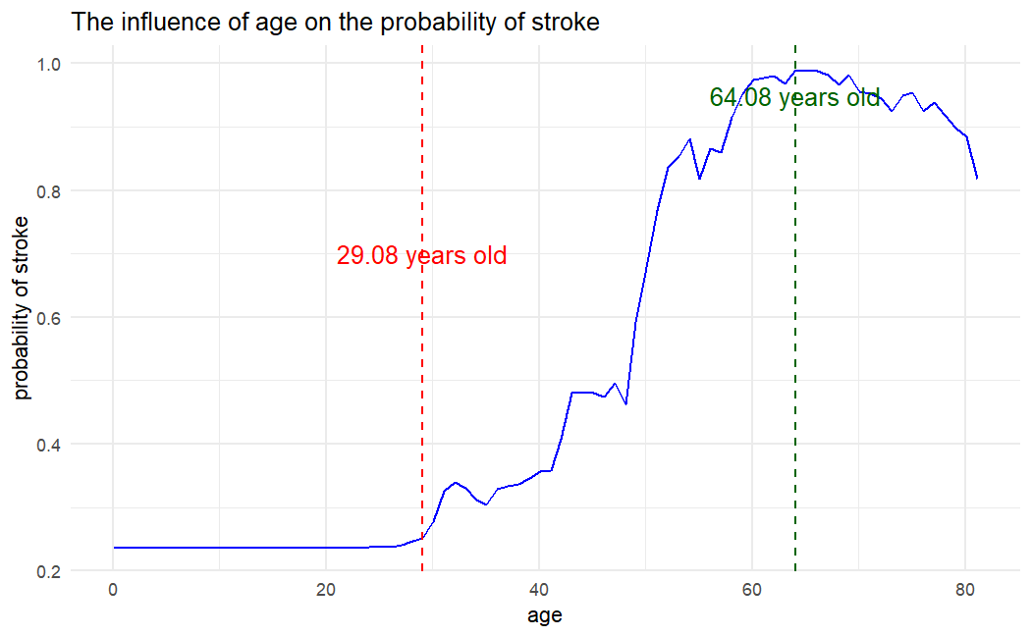
Figure3: By isolating the influence of age, we determined two critical thresholds through model predictive analysis: 29.08 years old (marked in red) is the starting point at which the risk of stroke begins to rise rapidly, which is calculated based on the rate of change of probability; 64.08 years old, marked in green, is the age when the risk reaches its peak.

Figure 3: Age × Stroke

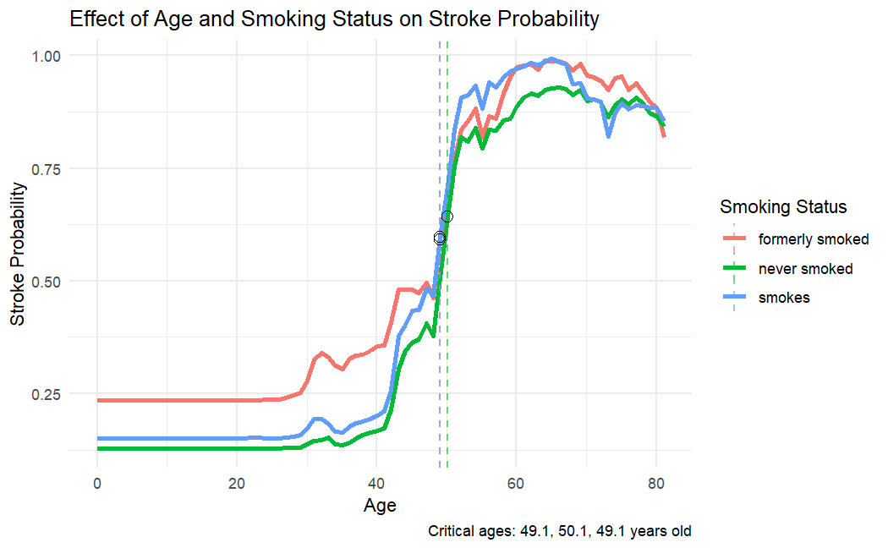
Figure 4: Further analysis revealed the interaction between age and smoking. Although the risk of stroke increases with age for all populations, the risk for smokers grows even faster. And at the same age, the probability of stroke among smokers is always higher than that among non-smokers.

Figure 4: (Age & Smoke) × Stroke

Figure5: We visualized the combined effects of age and blood sugar using a heat map. The yellow inflection point indicates the interval in which these factors jointly exert the strongest influence, which is automatically detected through trend analysis. This indicates that with age, high blood sugar significantly increases the risk of stroke. Especially people aged 60 to 70 with high blood sugar are the group most prone to stroke.

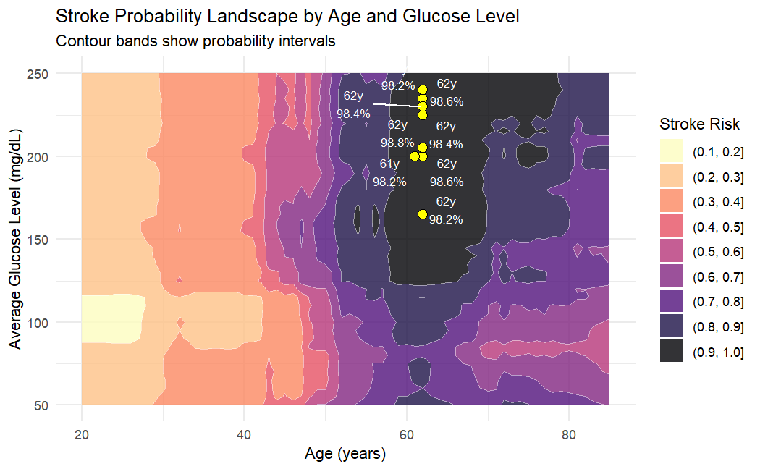

Figure 5: (Age & Glucose Level) × Stroke

2 Classification Model training and evaluation
The dataset is divided into 70% of the training set and 30% of the test set. The model performed well in terms of overall prediction accuracy, but its recognition ability (recall rate) for stroke cases was relatively low, only about 42%. This means that the model is relatively conservative and tends to avoid false positives while sacrificing some false positives.
Kappa measures the degree of improvement of the model compared with random classification, and 0.4455 is at a medium level.
The accuracy rate indicates that the overall accuracy rate of the model is 95.31%, which looks good, but is greatly affected by data imbalance.
The recall rate shows that 41.89% of the cases were correctly identified, and the underreporting rate was relatively high (58.11% were not identified).
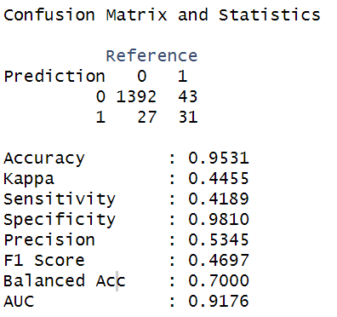
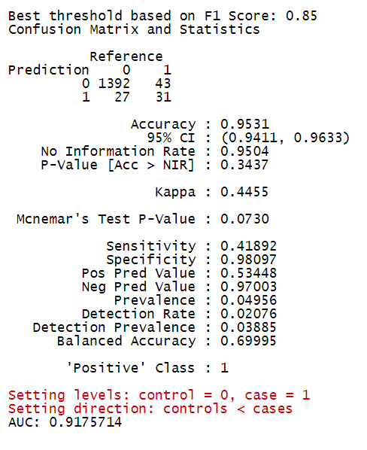
Specificity indicates that among non-stroke individuals, 98.1% were accurately identified. The model is very accurate in identifying normal people.
The accuracy rate indicates that among those predicted to have a stroke, only 53.45% actually had a stroke, and the false positive rate was relatively high (46.55%).
Neg Pred Value Among those predicted to be non-stroke, 97% are actually non-stroke. Stroke patients are rarely mistakenly predicted to be healthy。(Figure7，8)

Figure 6
Figure 7

This model performs well in discriminating ability (AUC) and identifying non-stroke groups, but has obvious deficiencies in the core of clinical application - the accurate identification of stroke patients. Considering the severity of stroke and the need for prevention and treatment, the current model is suitable for the first step of auxiliary screening. Further optimization is needed to improve the sensitivity for normal patients in the future before it can truly become an effective tool for predicting stroke risk.

Discussion

Stroke prediction has long been a core concern for medical practitioners, policymakers and public health researchers. This exploratory data analysis (EDA) and machine learning project has provided several important findings that can support the early intervention and prevention strategies of stakeholders.
The most prominent conclusion of this analysis is that age has been identified as the most significant predictor of stroke. Through modeling and threshold analysis, we found that the risk of stroke began to rise sharply at about the age of 29 and peaked at around the age of 64. These findings are helpful for public health departments and clinicians to more precisely identify the targets of screening and preventive education, especially those approaching the high-risk threshold.
Boehme et al. pointed out, "Stroke is an age-related disease..." After the age of 55, the incidence of stroke almost doubles for every additional 10 years. In addition, the study found that the average age of onset of ischemic stroke in 2005 was approximately 69 years old. These results consistently indicate that the risk of stroke rises rapidly from middle age and peaks in old age (approximately 65 years old) [2].
Interaction analysis further indicates that smoking status and blood glucose levels significantly amplify the impact of age on the risk of stroke. We found that the probability of stroke among smokers remained consistently higher than that among non-smokers at all ages. Studies have pointed out that smoking is an important risk factor for stroke. As the amount of smoking increases, the risk of stroke rises significantly, almost doubling the risk [2]. Individuals aged 60 to 70 with elevated blood sugar levels have the highest risk. Mosenzon et al. pointed out that the risk of stroke in patients with diabetes is 1.5 to 2 times that of non-diabetic patients [4]. In a study targeting the United States, Iveson et al. pointed out that approximately a quarter of people over 65 years old in the United States have diabetes, and the risk of cardiovascular complications for diabetic patients increases sharply with age. Therefore, high blood sugar further amplifies the risk of stroke in the elderly population, especially those aged 60 to 70.
For pharmaceutical and biomedical enterprises, the results of this study emphasize the importance of continuous research on age. Furthermore, health technology and artificial intelligence developers can utilize this discovery to optimize clinical prediction tools, especially in the context of an increasingly aging population.
Meanwhile, the limitations of the model cannot be ignored either. From the perspective of model performance, although the random forest classifier has a relatively high accuracy rate (95.31%) and specificity (98.1%), its recall rate for stroke cases is not satisfactory (only about 42%). This limitation stems from the category imbalance problem where non-stroke cases dominate in the dataset. As Chen et al. stated, in datasets with extremely imbalanced categories, random forests tend to predict the majority classes first, resulting in a decrease in the prediction accuracy of the minority classes (stroke cases) [3]. In other words, the RF model often has more false negatives (low recall rate) and fewer false positives (high specificity) on imbalanced data. Therefore, when no balancing processing is carried out, the random forest may have the problem of high accuracy and high specificity, but a low recall rate for positive samples of stroke.
In conclusion, the results of this study provide actionable insights for multiple stakeholders, including public health institutions, clinicians, digital health innovators, and researchers. Despite its limitations, this analysis demonstrates the potential of machine learning in the stratification of stroke risk at the population level and opens up new paths for the development of more targeted and data-driven prevention strategies.

References
[1] J. SoftTech, "Brain Stroke Dataset," Kaggle, [Online]. Available:
https://www.kaggle.com/datasets/jillanisofttech/brain-stroke-dataset. [Accessed: May 4, 2025]
[2] A. K. Boehme, C. Esenwa, and M. S. V. Elkind, "Stroke Risk Factors, Genetics, and Prevention," Circulation Research, vol. 120, no. 3, pp. 472–495, Feb. 2017, doi: 10.1161/CIRCRESAHA.116.308398. [Online]. Available: https://www.ncbi.nlm.nih.gov/pmc/articles/PMC5321635/
[3] C. Chen, A. Liaw, and L. Breiman, Using Random Forest to Learn Imbalanced Data. Berkeley, CA, USA: University of California, 2004. [Online]. Available: https://statistics.berkeley.edu/sites/default/files/tech-reports/666.pdf
[4] J. Stroke, "Diabetes and Stroke: What Are the Connections?," J Stroke, vol. 25, no. 1, pp. 26–38, Jan. 2023, doi: 10.5853/jos.2022.02306. [Online]. Available: https://www.ncbi.nlm.nih.gov/pmc/articles/PMC9911852/
[5]J. B. Halter et al., "Diabetes and cardiovascular disease in older adults: current status and future directions," Diabetes, vol. 63, no. 8, pp. 2578–2589, Aug. 2014, doi: 10.2337/db14-0020. [Online]. Available: https://pubmed.ncbi.nlm.nih.gov/25060886/

